1. 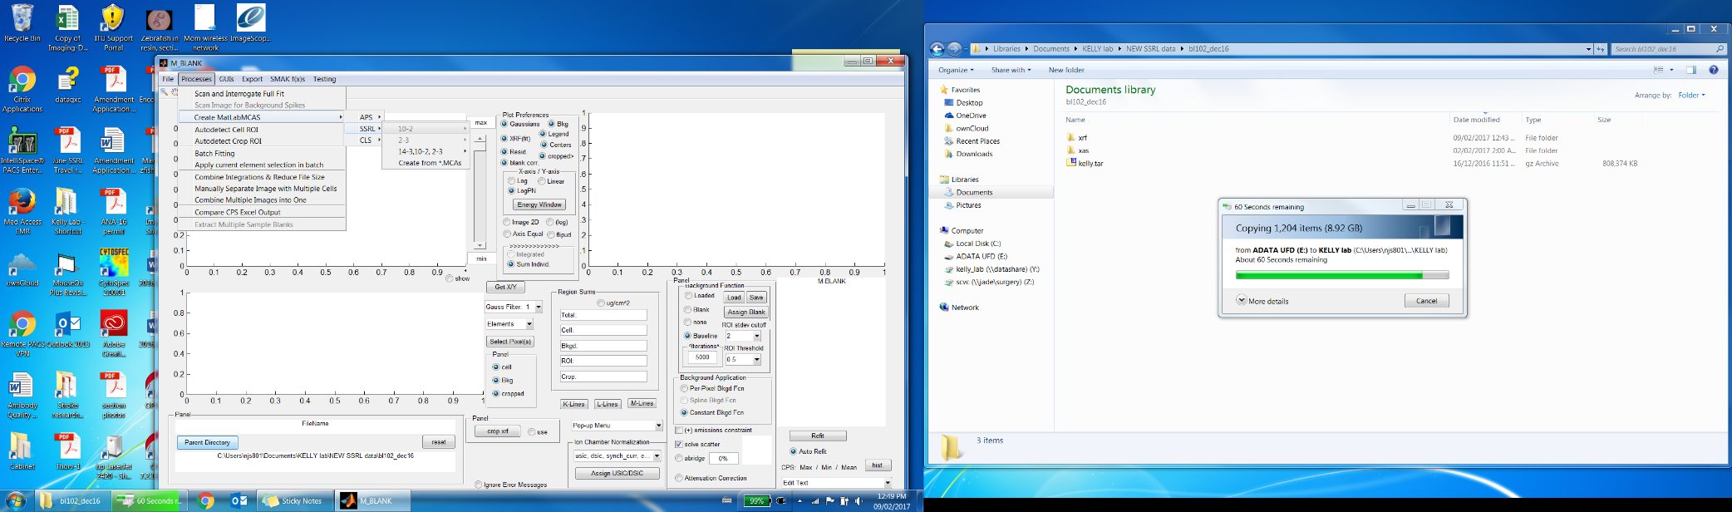Start by setting the parent directory. Click on ‘Parent Directory’ and select the folder containing all the files from one beamtime.
2. 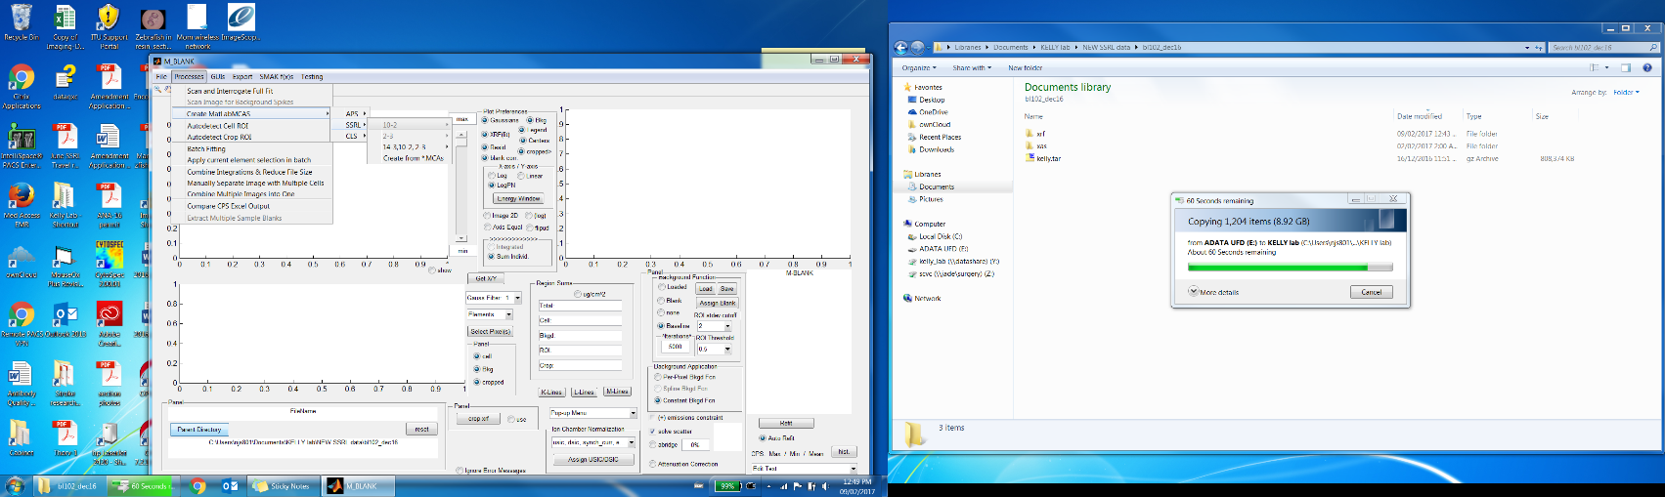Create Matlab files from the tar.gz files
   1. Go to ‘Processes’, ‘Create Matlab MCAs’, ‘SSRL’ and select beamline, then select ‘tar’
   2. 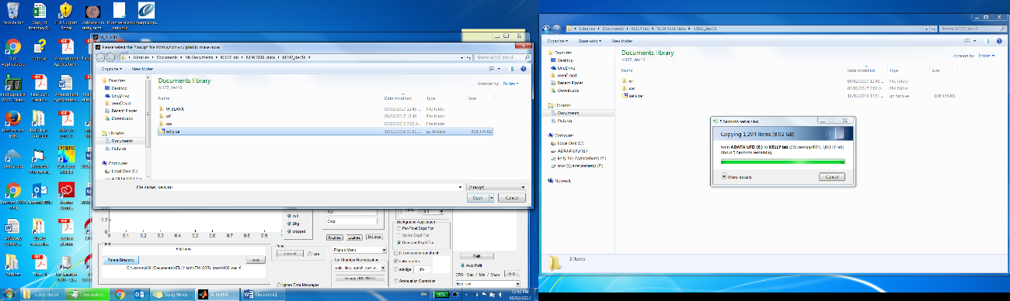When the folder pops up, select the .tar file inside the beamtime folder (i.e. Kelly.tar) and click ‘open’
   3. Then select the ‘XRF’ folder and click ‘select folder’. Wait.
   4. 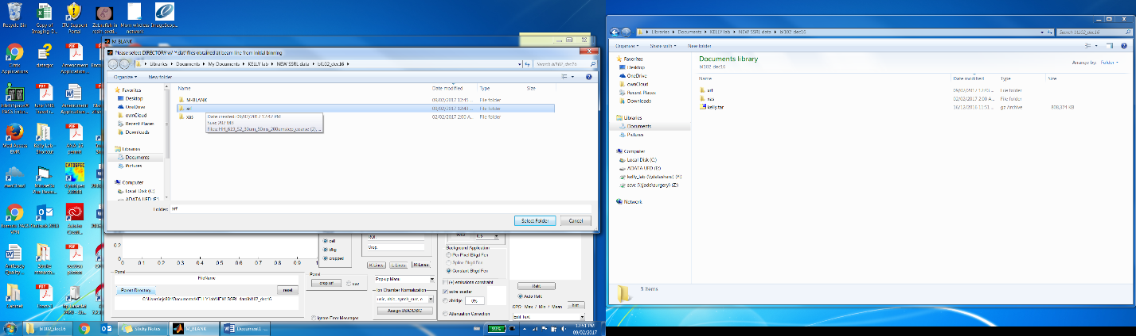Then click ‘Select All’, or only pick the files you plan on using (to save time, but you might as well do all the files so you can fit them all at once)
   5. It will ask you for the excitation energy – if you’re not sure, it should be in the file name, or you can type ‘10000:15000’ for BL 10-2 and 2-3 if you really don’t remember
   6. 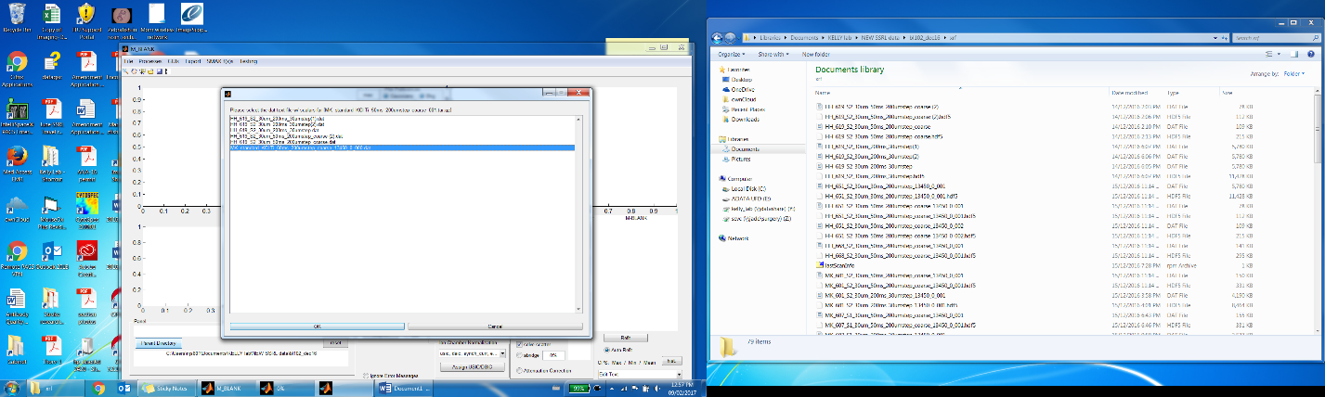The next window will ask you if this is XASI – answer No
   7. If there are any files that can’t be paired automatically then toss them – it means there’s no .dat file in the folder which means we had probably aborted the scan or something. Press ‘esc’ if can’t pair.
   8. Designate the units – if the step size was 0.03x0.03 (i.e. 10-2), the
   9. n in mm.
   10. Scalars? – select all, then ‘ok’
   11. 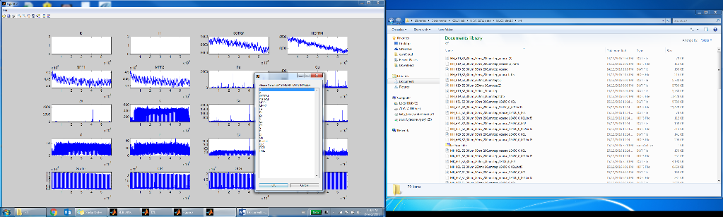Up stream ion chamber? For BL 10-2 and 2-3, select I0STRM. For 14-3, I1.
   12. Down stream ion chamber? For Bl 10-2 and 2-3, select I1STRM. For 14-3, I2.
   13. Wait for a while… Once the bars are done, close the window

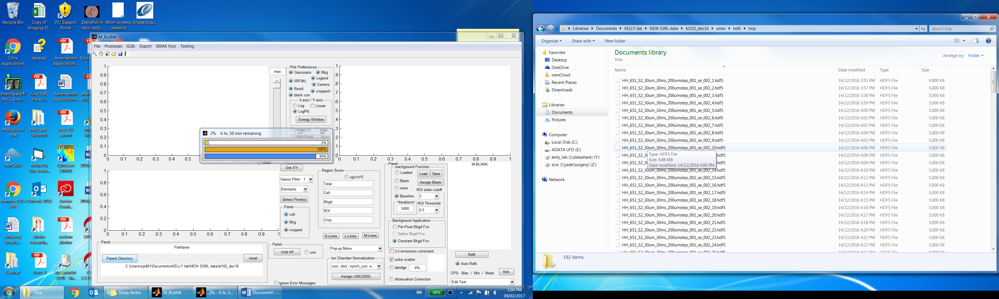

1. 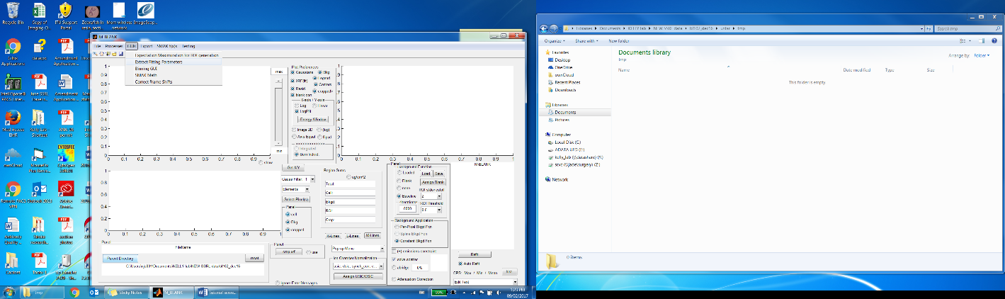Coarse fitting the parameters
   1. Go to ‘GUIs’, then ‘Extract fitting parameters’
   2. 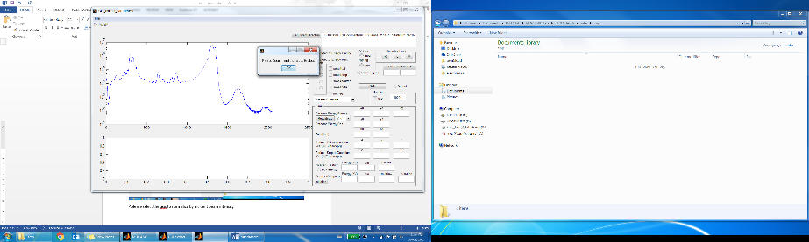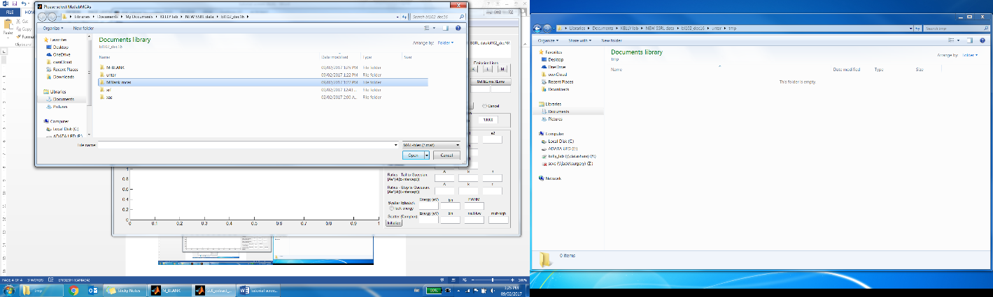Go to ‘File’, ‘load’, Previous load? ‘No’ (unless had previously loaded the MCAs). Select the Matlab MCAs ‘MBlank _MCAs’. Select as many files here as you want – the more files the better (better signal to noise ratio, for sure should use all the fine scans in the folder).
   3. Background pixels? ‘yes’ if there are background pixels in the scan. Wait…
   4. Select up stream ion chamber – I0 for 10-2 and 2-3. Wait…
   5. 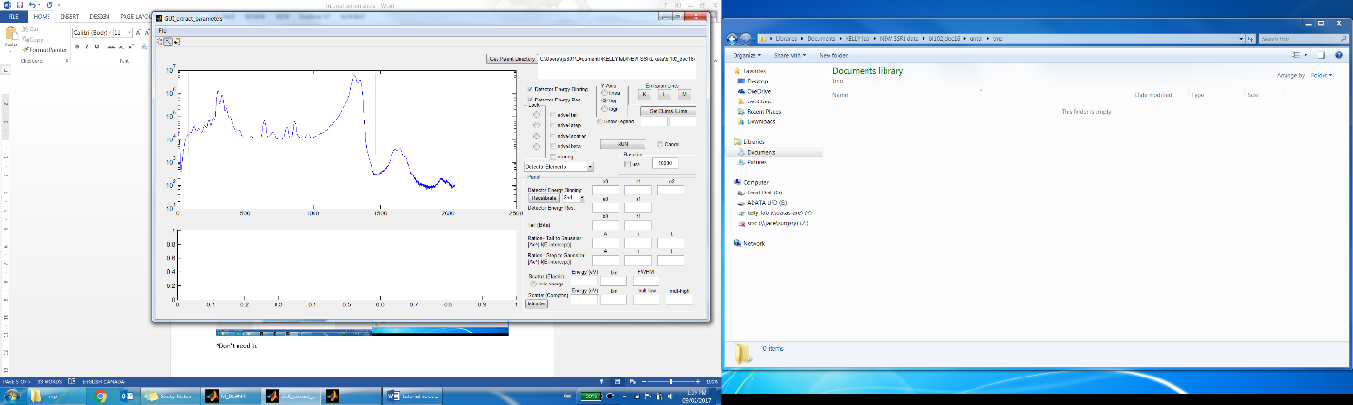Zoom in on spectra (optional), click ‘ok’
   6. 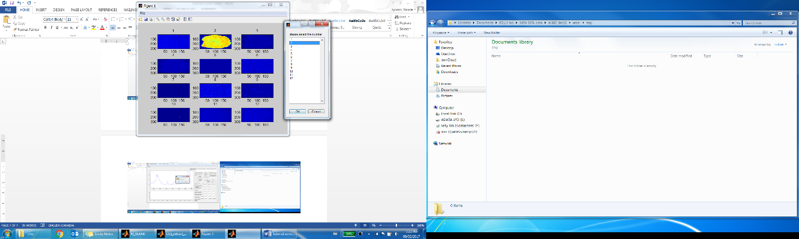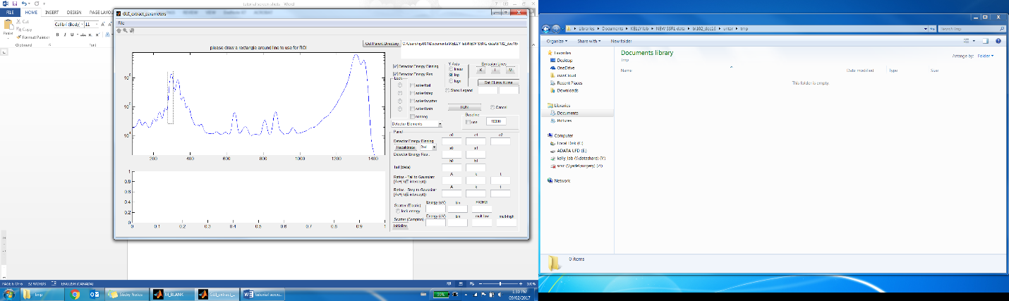Go through and select each peak and click ‘yes’ after each one (select 5-15). Select ‘no’ when done
   7. It will show you the outline of the sample – select appropriate window and click ok
   8. 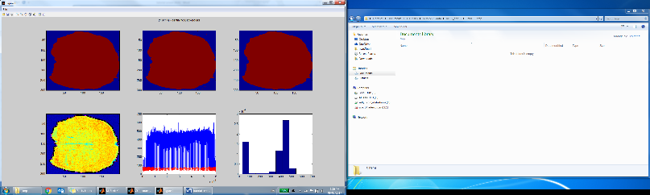Selection mode? ‘Manual (image)’ if you know what you are doing – it will ask you to draw a shape (by clicking) around your tissue, which can be better so you ensure your whole tissue is included. New users should select ‘automatic’ unless the data is noisy
   9. It will show panels partitioning sample vs background – auto works most of the time
   10. 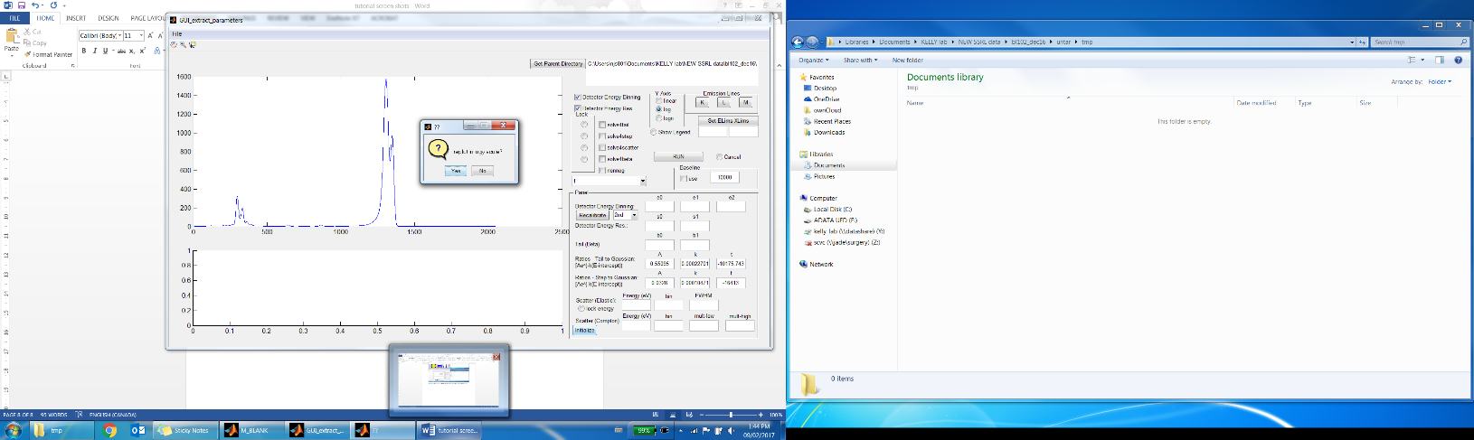Reset GUI? No, if similar data compared to the last beamtime
   11. Save session “sample_parameters_12500”
   12. Ignore ‘Please draw rectangle around line…’
   13. Click ‘initialize’
   14. Replot as log? No
   15. Double click above excitation peak of scatter. Put in energy (12500) and push enter.
   16. ‘Select zero’, push enter
   17. 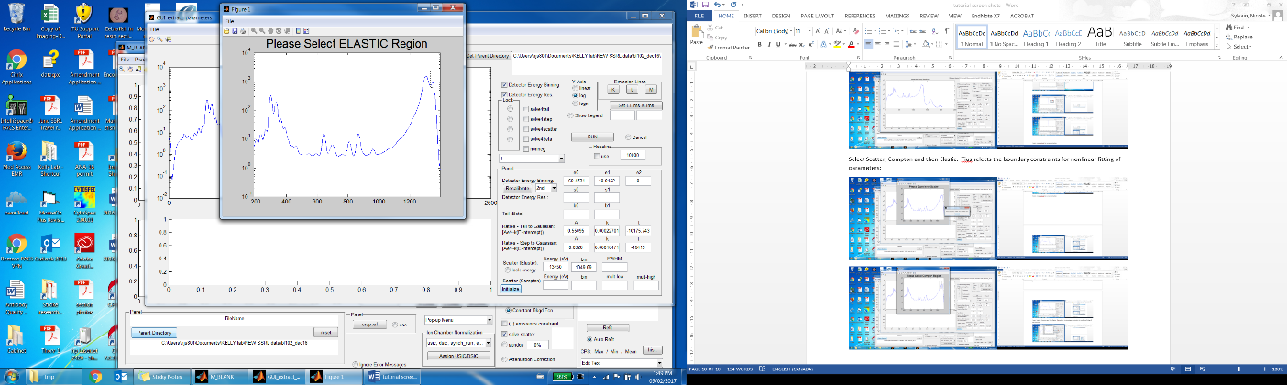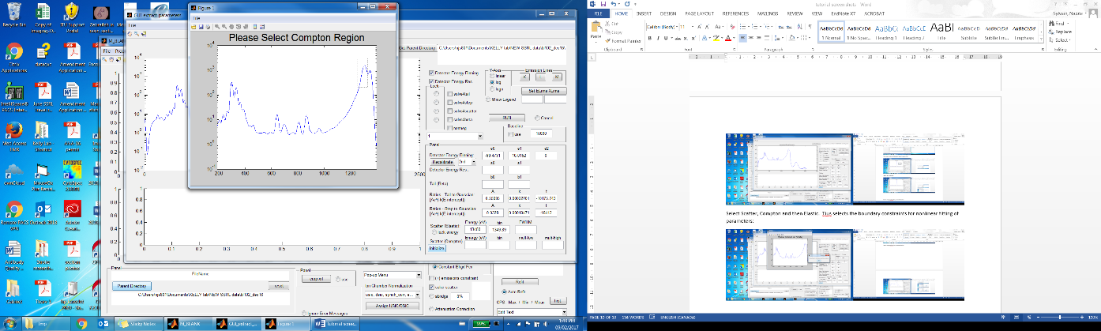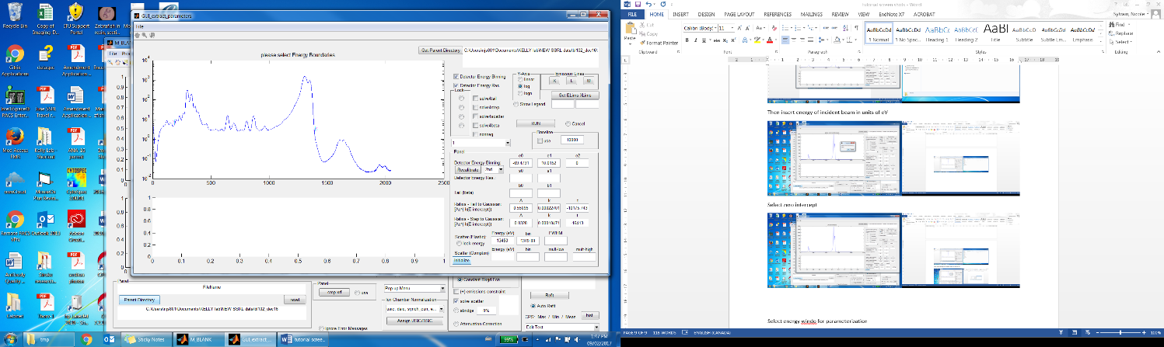Boundaries – select each edge (excluding pile up), hit enter
   18. Zoom in on spectra, Draw a box around the whole scatter peak, then draw a box around the Compton peak (on left) and then a box around elastic scatter (right peak)
   19. 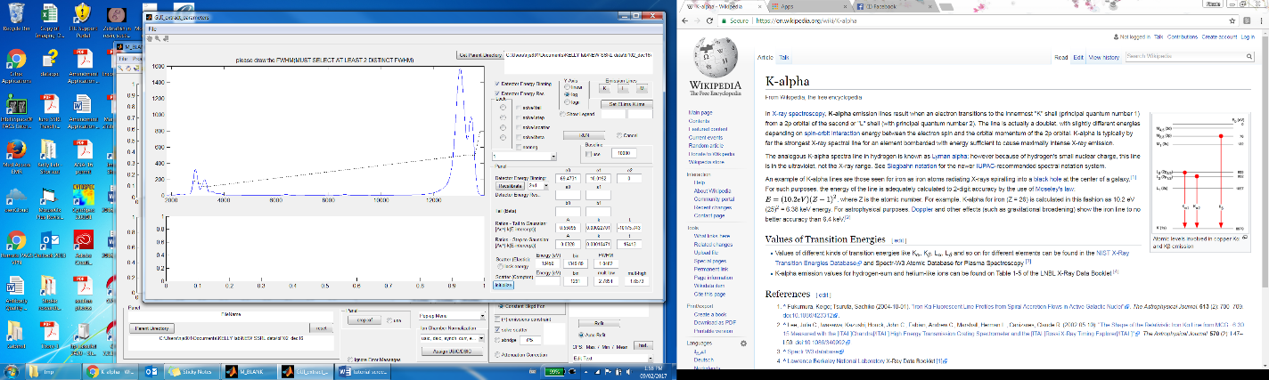Select K emission lines (P,S, Cl, Ar, K, Ca, Mn, Fe, Cu, Zn) and select L an M lines if interested in those elements.
   20. Select half widths of each peak by click the left side and the right side of each side half way up peak (red line will ties all the peaks together) Need at least 2 peaks (4 points). Push enter. Save session. Click run.
2. Refining the parameters: now we have created the initial parameter seeds – need to refine. The steps needed to do this will be very sample dependant.
   1. I usually refine the “Detector Energy Res.” (Energy Calibration) Or “Detector Energy Binning” (FWHM) individually at first. If the parameter starts really screwing up, “CANCEL” and choose the other. Detector energy binning turns bineed counts into energy peaks, while Detector energy res has to do with full width/half max values (it widens or narrows peaks).
      1. Deselect ‘detector energy binning’ and click run.
      2. 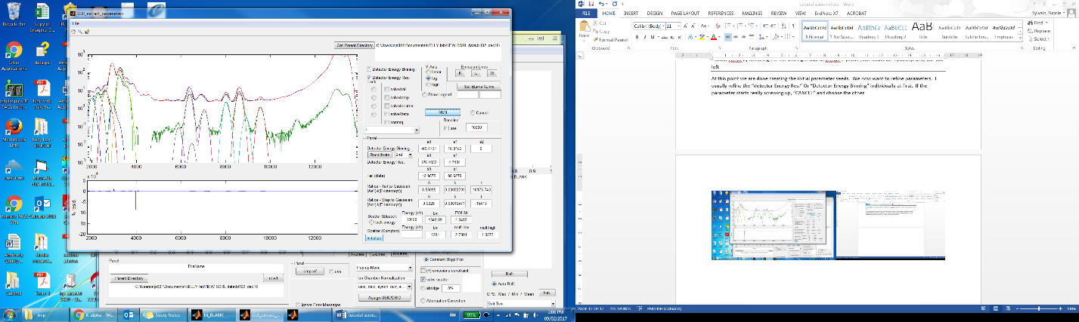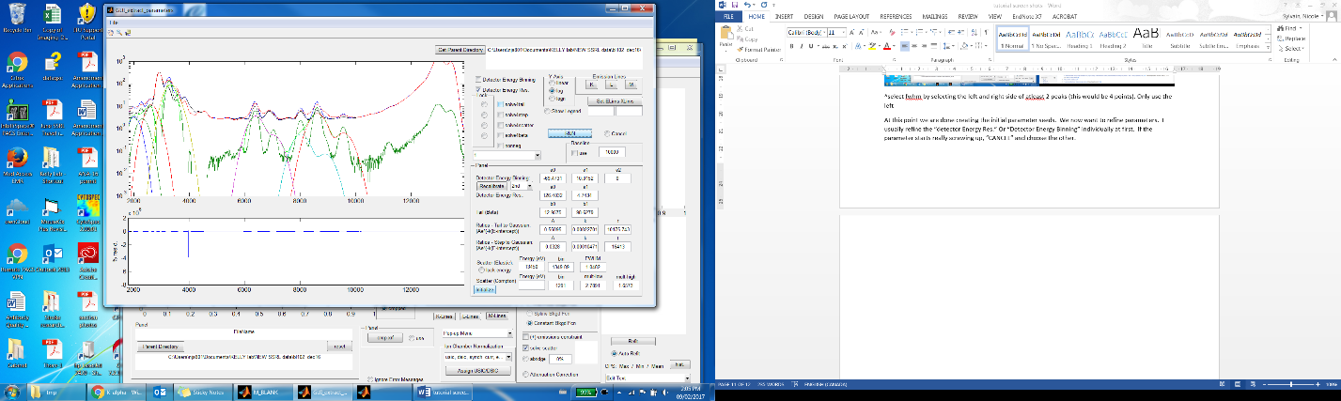Deselect ‘Detector energy Res’ and select’ Detector energy binning’ and click run.
      3. 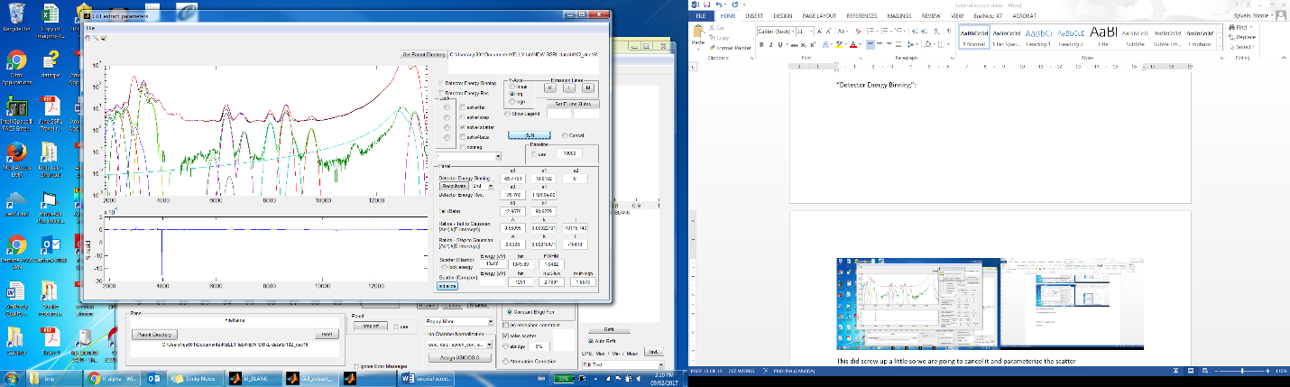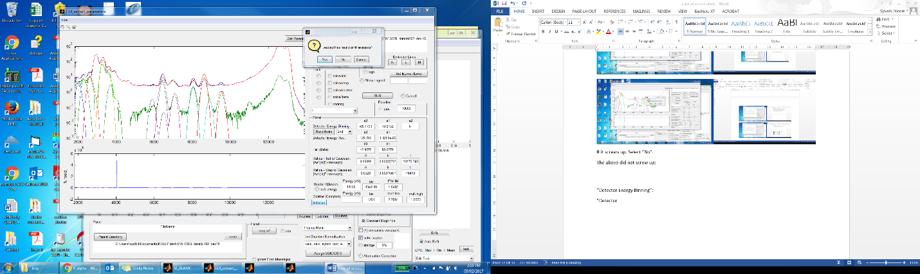This did screw up a little so we are going to cancel it and parameterize the scatter
   2. 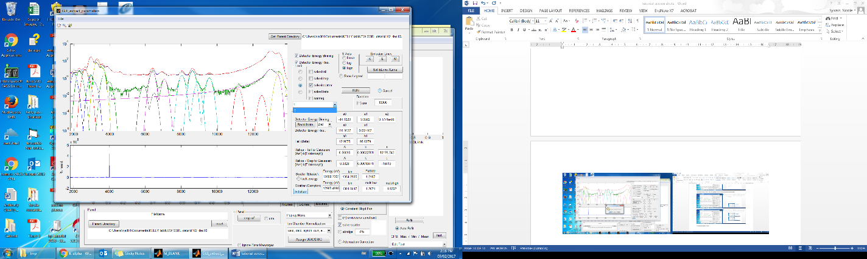Accept revisions after every round if it improved. For any round of revision, click cancel if it starts looking better instead of waiting for it to finish – sometimes it ends up looking worse at the end of the sequence.
   3. Deselect ‘Detector energy binning’ and ‘Detector energy res’, and click ‘solved scatter’, click ‘run’ – this parameterizes the Compton and elastic scatter.
   4. We added Se and then locked the Scatter and fit for both Energy Calibration and FWHM:
   5. 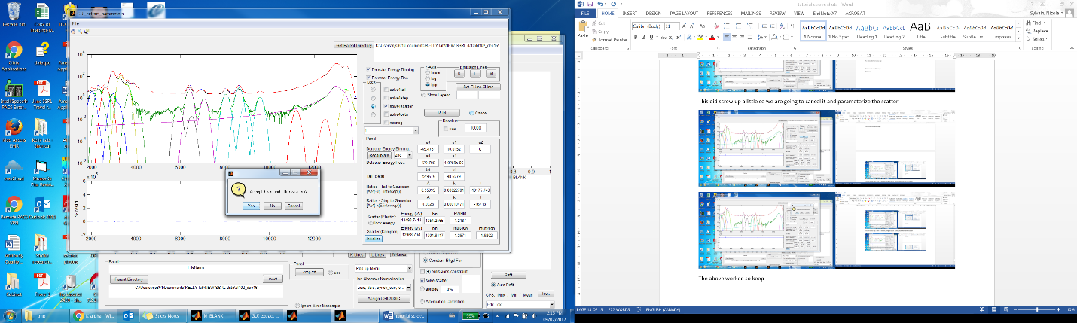Can tell if fit is good by zooming in and seeing if the green lines fit emission lines. Save fit when happy. Then ‘extract parameters’.
   6. If the bars are really wide and can’t be fixed, you can select first order (beside the recalibrate button)and select peaks for which you know the element with certainty (Fe, Zn, P, K) – select the peaks then tell it which elements those are. Select Detector Energy Binning and click run. If you have 3 or more good known elements, can do 2nd order recalibration. Run again with settings mentioned above.
   7. For other data sets (14-3) you will have 4 different detector elements that need to be parameterized (even though 2-4 do not contain any data).
   8. To see legend of line colours, click ‘show legend’ and click run.
   9. Save Session (if you gave it more than one file it will catenate them all together and the file name will most likely be too long. So name it something like “Samples Params” or “Standard Params”). Include the date or version number.
   10. Go under ‘File’ and ‘Extract parameters’
3. Standardizing (calibrating counts to ug/cm^2):
   1. In the main MBlank window, go under ‘File’ and go ‘Load fitting parameters’
   2. 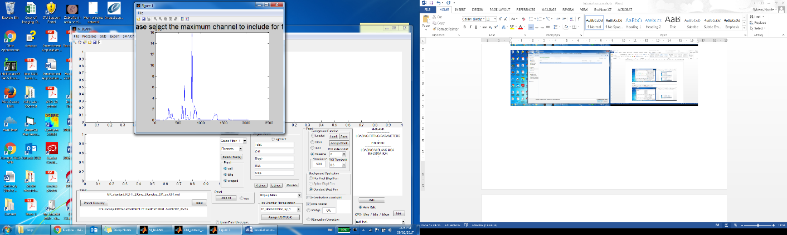Go under ‘File’ and ‘Load Matlab MCAs’, go in folder ‘Mblank_MCAs’ and select one of the scans of the standards
   3. ‘Rest GUI?’ No
   4. ‘select the maximum channel to include’ click on far right of spectra and press enter
   5. Assigning the blank:
      1. Look at the phosphorous window and adjust the levels until you can see an outline of all the standards.
      2. 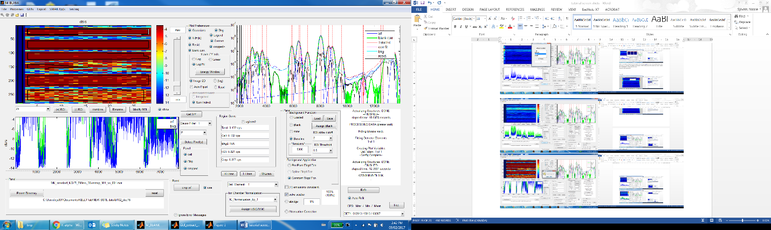Click on ‘Assign blank’ (located in the Background function box. It will ask ‘Assign from image or plot?’, select ‘plot’. Modify existing ROI?’ No. In the spectra window (bottom left), draw a box around the bottom half of the spectra.
      3. If the blank looks odd (shows up as light blue line in the window on the right), then assign the blank again but not select as much of the spectra or use a different element map.
   6. Click ‘Crop XRF’ (middle of screen, bottom).
      1. It will ask ‘Add to existing crop?” No.
      2. 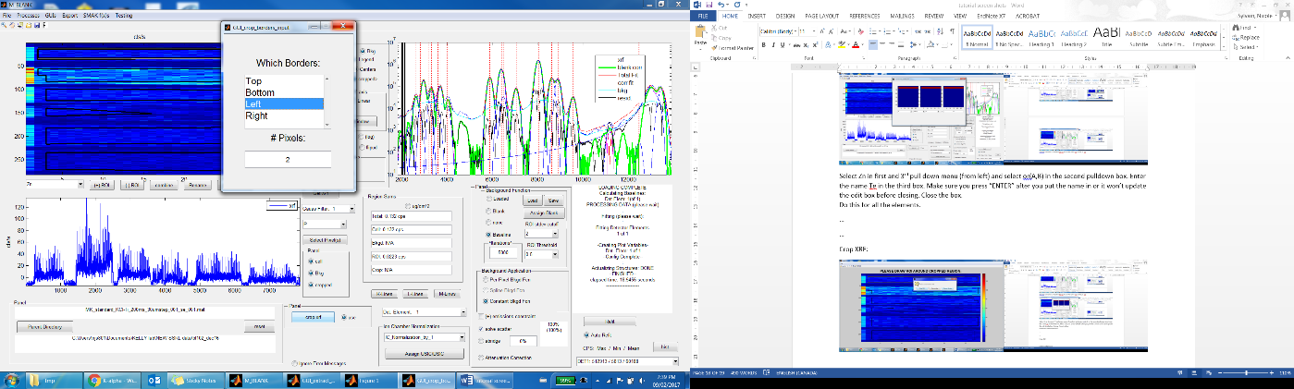Then it will give you the option of ‘Draw ROI’, ‘Remove Max’ or ‘Remove borders’ – select ‘Remove borders’.
      3. Select ‘left’ and # of pixels = 2. Press enter and close box. Wait until finished
   7. If detector was saturated, then you will see the peaks of the fit are shifted relative to the standard peaks. You’ll need to create a parameter files for the standards only. This can be done using ‘Extract parameters’ under ‘GUIs’ and a scan of the standards.
   8. 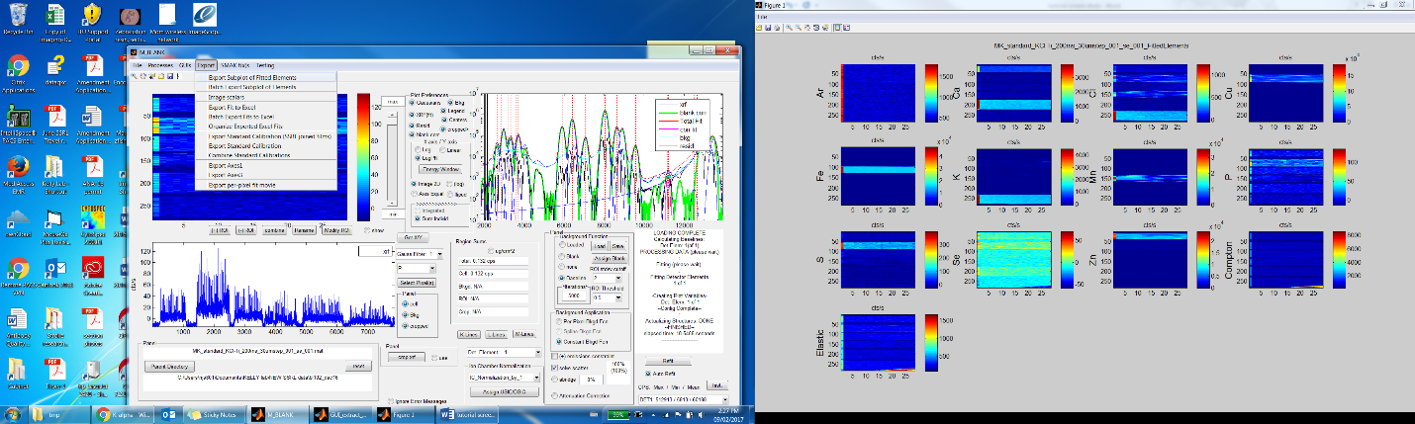Go under ‘Export’ and click ‘Export of subplot of fitted elements’ (to know which region is which element).
      1. ‘Normalize Images by elastic?’ No.
      2. Elements? Select All.
      3. ‘Draw ROI?’ No.
      4. ‘List CPS?’ No
      5. ‘Is user happy? Press Esc
      6. ‘Save image?’ Not necessary, so no.
      7. 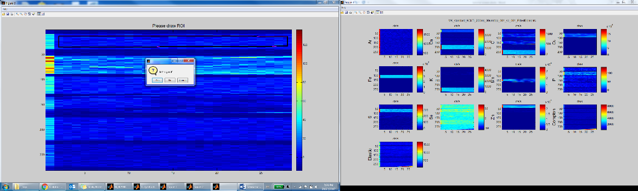Do not close window, but minimize to tray or slide to adjacent monitor.
   9. Now we will need to assign an ROI from each element in the scan you have open.
      1. Click on ‘(+) ROI’’ (button under main image). Draw a box around the first element by clicking where you want the four corners. Double click at the end to make sure first and last point are joined.
      2. Right click while mouse is inside the box, and select create mask. It will ask you ‘is this good?’, select Yes, or No to redraw box.
      3. ROI name? Select ‘Other’, then ‘Ok’, then name the element.
      4. If there are 2 elements of interested in one standard (i.e. KCl), then name the scan with the first element (K). You’ll duplicate the ROI by clicking ‘combine’, selecting ‘K’ in the first box, selecting ‘or(A,B)’ in the second box, ‘K’ in the third box, then putting the name of the second element (Cl) in the last box. Press enter. Press the X to close the box. Both ROI should be in the list beside ‘(+)ROI’.

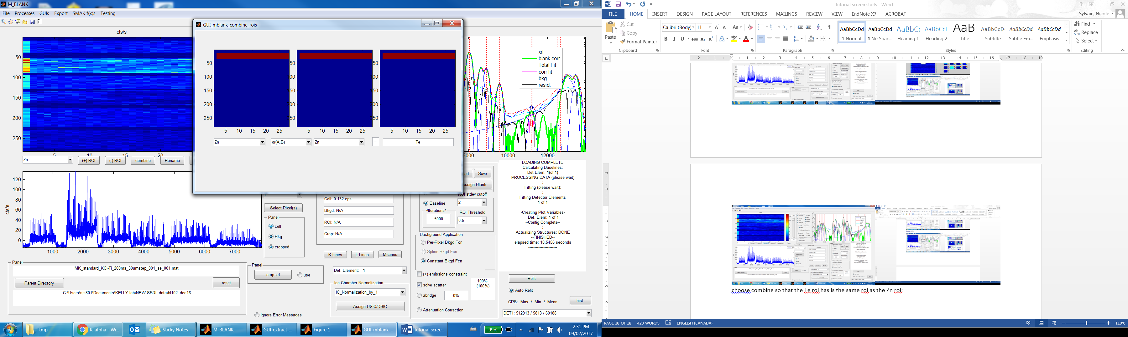

* + 1. Repeat for each standard in the scan.
    2. Save session.
  1. Exporting the standard calibration
     1. Go under ‘Export’, then ‘Export Standard calibration (SSRL joined films)’. Find folder ‘MK_APR16_SSRL’, go in folder ‘2-3’, and select excel file for each element currently in the open scan. 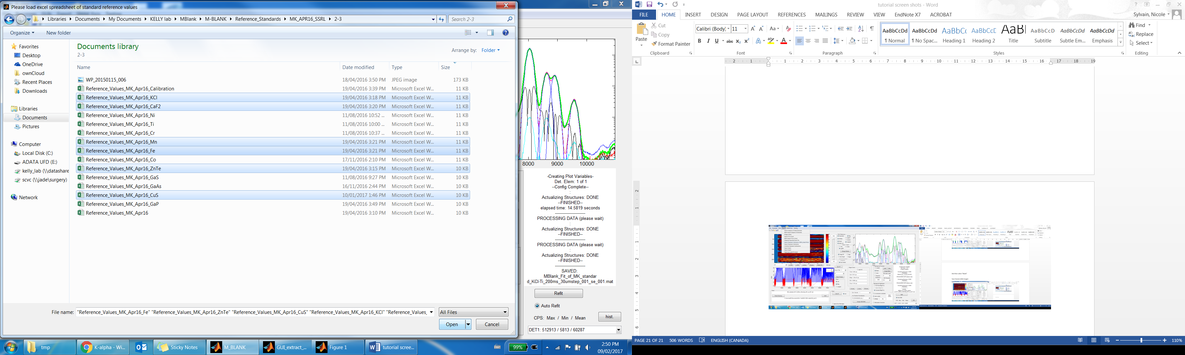
     2. It will ask ‘Please select the ROIs…’, click ‘Select all’ and ‘OK’. Wait…
     3. 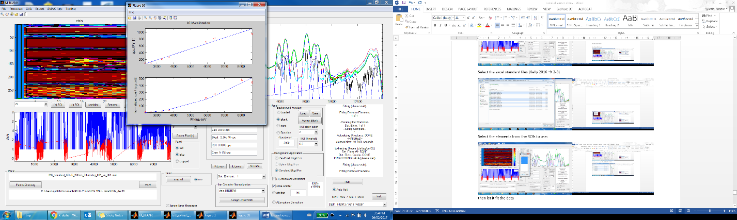It will show a curve f where the elements fit. Can remove points if they appear to be outlyers by not selecting those elements when you export again – but this is subjective.
  2. 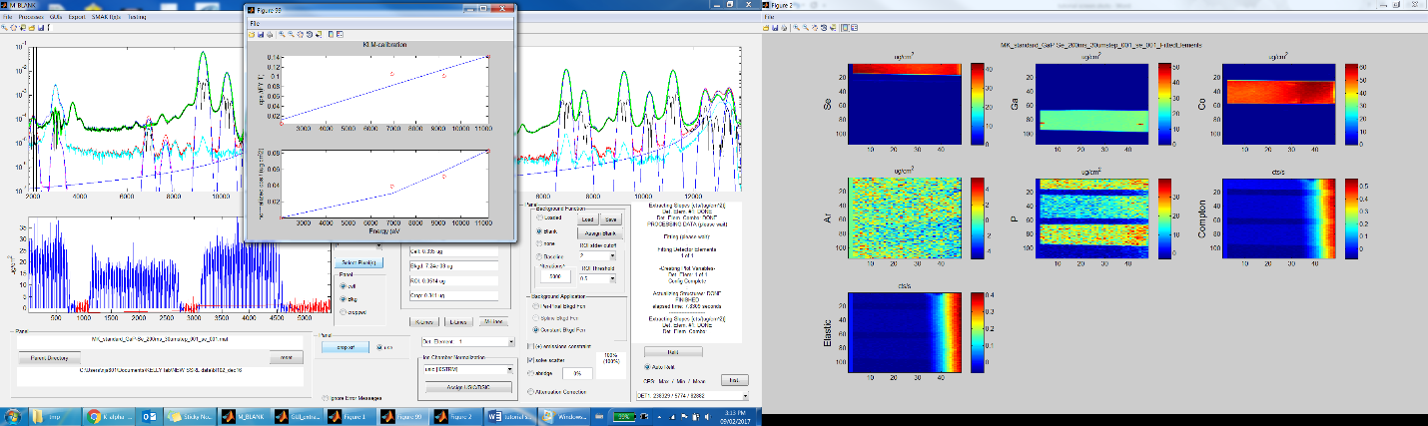Open the other standard scans, if you images the standards in different scans and repeat all steps.
  3. 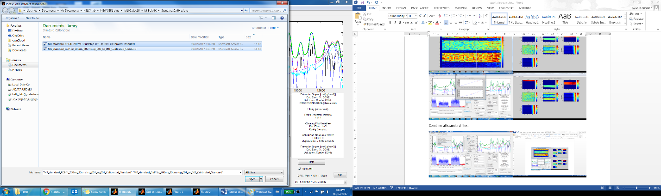Then combine the standard files by going under ‘Export’ and click ‘Combine Standard calibrations’ and selecting all the standard calibration files
  4. 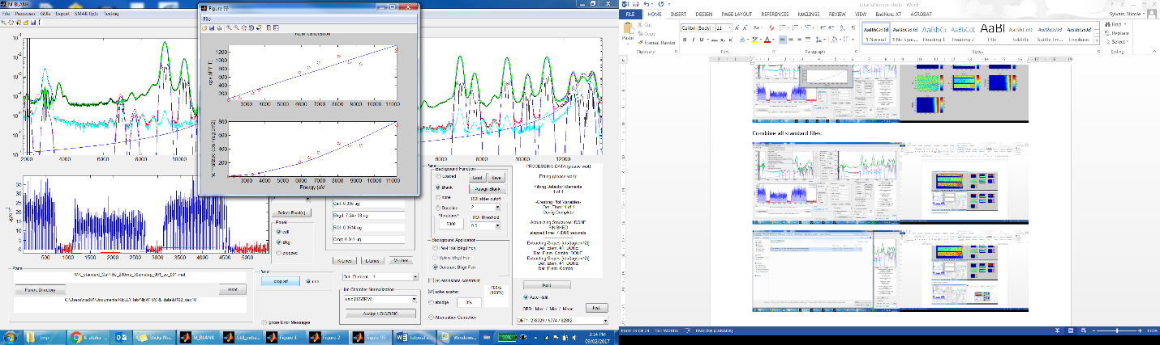Should get something like this:

1. Fitting the first sample of a beamtime:
   1. Go to ‘File’, click ‘Load standard calibration’ and select combined file.
   2. Go under ‘file’, click ‘Load Matlab MCAs’ and select one good scan from that beamtime. Click refit
   3. If image is displaying only as spectra, click ‘Image 2D’.
   4. ‘Reset Gui to default?’ No
   5. ‘Select Max’ – click on right side of spectra and push enter. Wait
   6. Select proper K and L lines and click ‘Refit’ (bottom right)
   7. 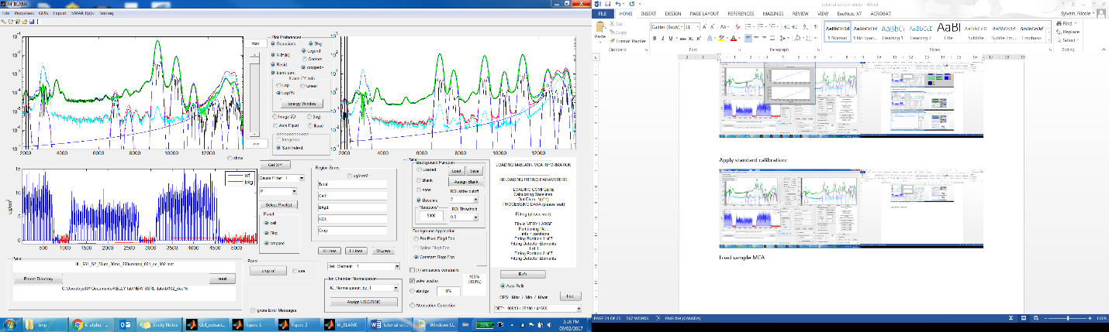Click ‘Crop XRF’ (bottom, middle), select ‘left’ and ‘2’ pixels
   8. Optional: change ROI std cutoff to 1 and ROI threshold to 0.1
   9. Go in ‘Processes’ and click ‘Autodetect cell ROI’, click refit
   10. Go under ‘File’, click ‘load fitting parameters’, find sample paramters file and click ‘load new’
   11. Save session, don’t change file name
2. Batch fitting
   1. Go under ‘Processes’, click ‘Batch fitting’, select ‘MBlank_MCAs’, select only fine scans or all scans that you want to fit
   2. ‘Autoblank?’ Yes, or apply saved blank
   3. 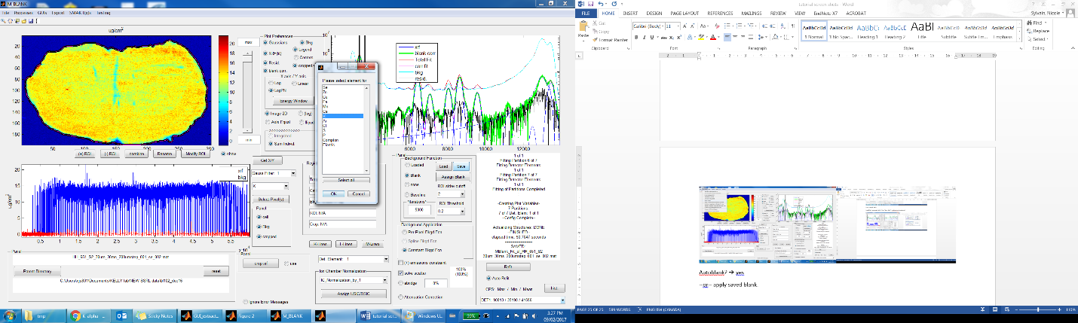Select element - K
   4. Recommended setting in GUI are “ROI Theshold is set to 0.2 and that ROI stdev cuttoff is set to 2. Optional: change ROI std cutoff to 1 and ROI threshold to 0.1
   5. ‘Crop borders?’ yes. Left, 2 pixels, press enter
   6. Wait! Watch fiels and note which ones have a badly fitted outline or scroll though all the files afterwards